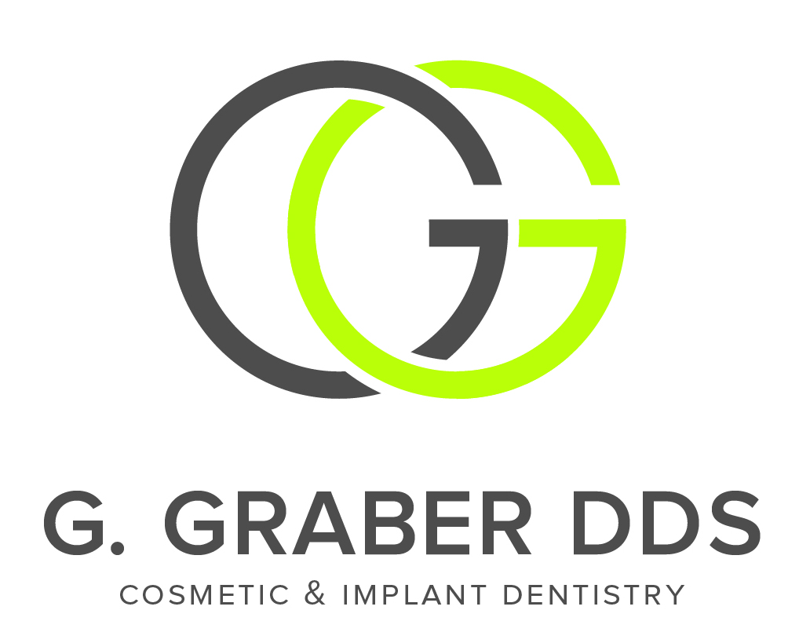

DENTAL HISTORY FORM

What is your immediate concern?
Have you lost any teeth? Y/N How? _______
Have you ever had or currently have growths or swelling in your mouth? Y/N Where? ___________
Do you avoid brushing any area of your mouth? Y/N Why? _______
Do you catch food between your teeth? Y/N Where? _______
Do you have dry mouth or lack of saliva? Y/N
Have you ever been told you have gum/periodontal disease? Y/N
Do you have any areas of discomfort in your mouth? Y/N Where?
Do you ever experience sore or stiff neck muscles? Y/N How often? _______
Is your jaw painful or locked when you get up in the morning? Y/N
Do you notice that you clench you teeth during the daytime hours? Y/N How often? _______
Do you or have you ever been told that you grind your teeth at night? Y/N
Do you have grating, clicking, cracking, or popping sounds in either or both joints when you chew or open your mouth? Y/N
Do you have difficulty chewing your food? Y/N
Have you ever experienced trauma to the chin, face, or head? Y/N When?____________________
Do you have an unpleasant taste or odor in your mouth? Y/N
What are your parents’ dental histories? Mother Father
How would you rate the appearance of your teeth? (Worst) 1 2 3 4 5 6 7 8 9 10 (Best)
Do you want to learn how to control dental disease and retain your teeth? Y/N
What can we do to make your dental visits more pleasant?
What would you change about your mouth if you didn’t have any obstacles?
What might those obstacles be?
Would you like your teeth pearly white and perfect or natural with pleasing irregularities?
How important is it for you to keep your teeth healthy, comfortable, and aesthetic for the rest of your life? _______
Do I have permission to tell you all of your dental needs? Y/N
Are you currently undergoing treatment with a dental specialist? Y/N Whom?

